# Assignment 5

In this Exercise, Unscented Transform has to be implemented using two given functions named *compute_sigma_points* and *recover_gaussian*. The idea of the unscented transform is to choose a set of points from the Gaussian distribution (similar to the real world) and convert them into another gaussian distribution using a non-linear transform g(x). First of all, it can be done by computing the sigma points but however it is not a guassian distribution anymore after the transform. Then try to recover the Gaussian by computing the $μ and ε$ from the obtained transform. Later on, the extended kalman filter can linearize the newly transform gaussian distribution (this part is beyond the scope of this assignment 5). The initial distribution ($μ and ε$) and initialized parameters (n, k, λ and β) have been already given. The sigma points $ℵ$ are calculated by

$$ℵ_{0}= μ$$

$$ℵ_{i}= μ+ \sqrt{\left(n+λ\right)ε} ℵ_{i-n}= μ- \sqrt{(n+λ)ε}$$

Once the sigma points is computed, the transform can be applied on it. The transform can be either linear or non-linear functions. The weights has to be assigned for each sigma points as

$$w_{m}^{0}=\frac{λ}{n+ λ} w_{c}^{0}= w_{m}^{0}+\left(1-σ^{2}+β\right) w_{m}^{i}= w_{c}^{i}= \frac{λ}{2(n+ λ)}$$

Therefore the equations for recovering the gaussian are

$$μ= \sum_{i=0}^{2n}{w_{m}^{i}{*g(ℵ}^{i})}$$

$$ε= \sum_{i=0}^{2n}{w_{c}^{i}{*g(ℵ}^{i}-μ)}{{*g(ℵ}^{i}-μ)}^{T}$$

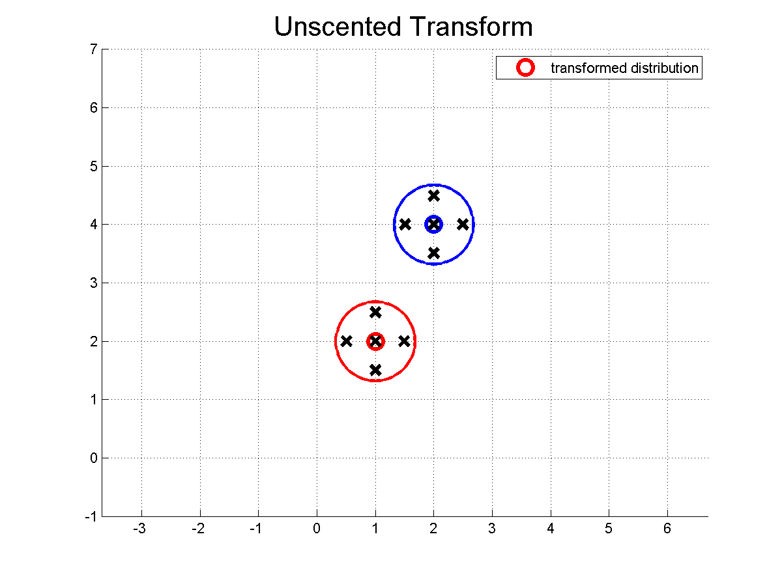

Figure 1: Linear Transform Function

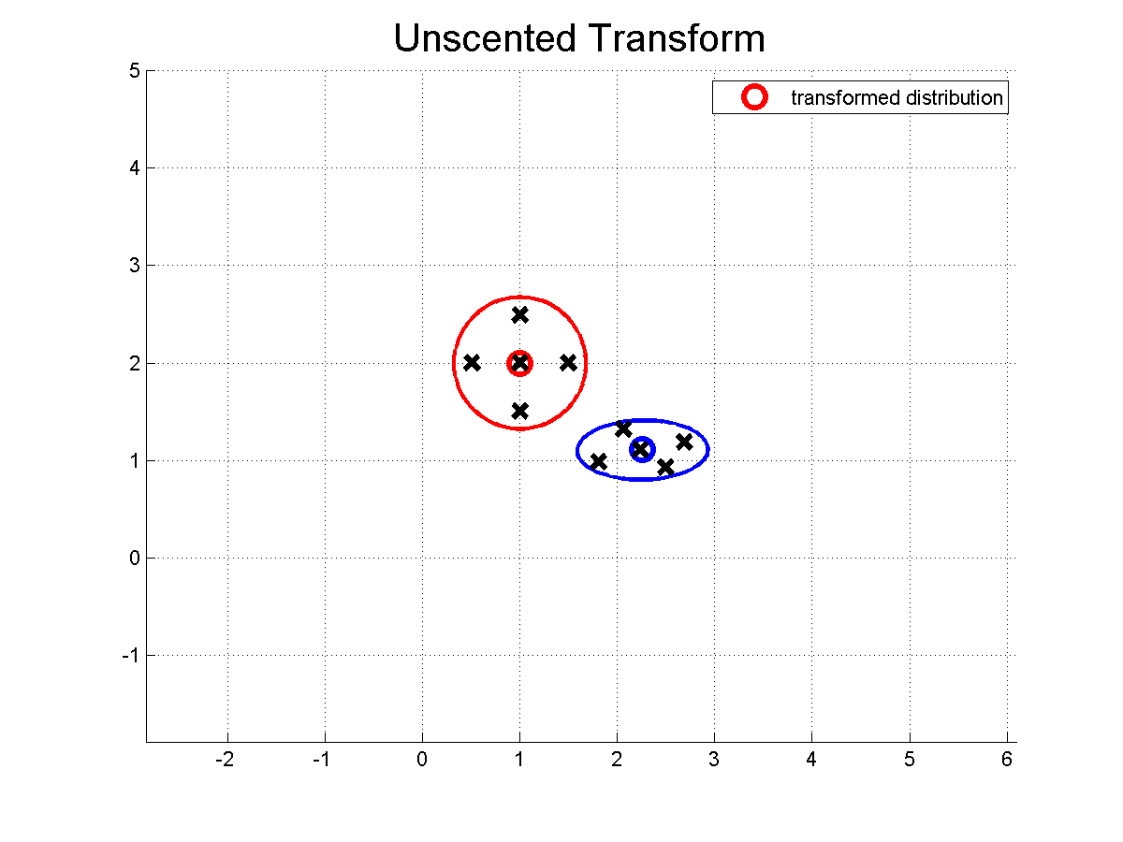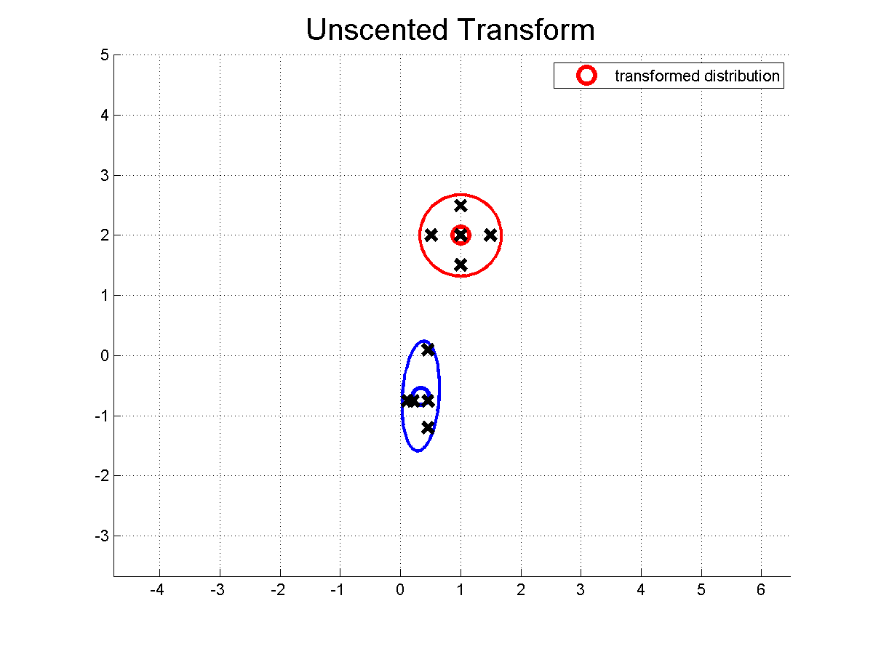

Figure 2: Polar Co-ordinates Transform

Figure 3: Non-linear Transform

In Figure 1, the sigma points are transformed using the simple linear equation so we can notice that the entire transform just moved a just little according to the linear equation. In the figure 2 and 3, the transform is done by non-linear equation so that the eigen values changes accordingly which leads to the ellipse shaped guassian distribution.

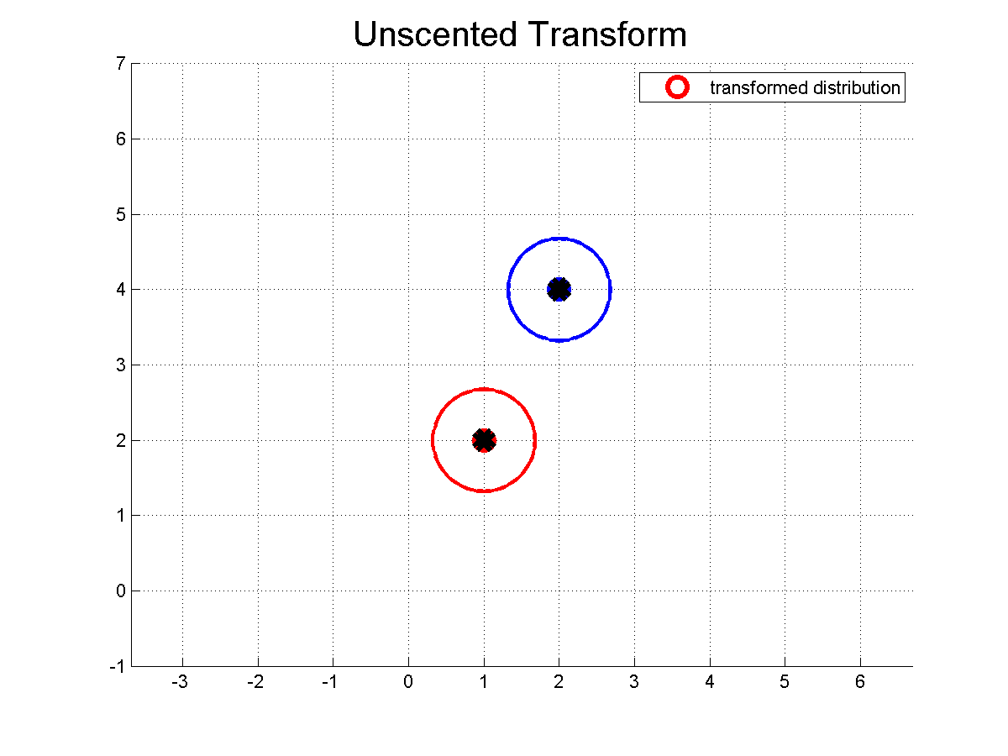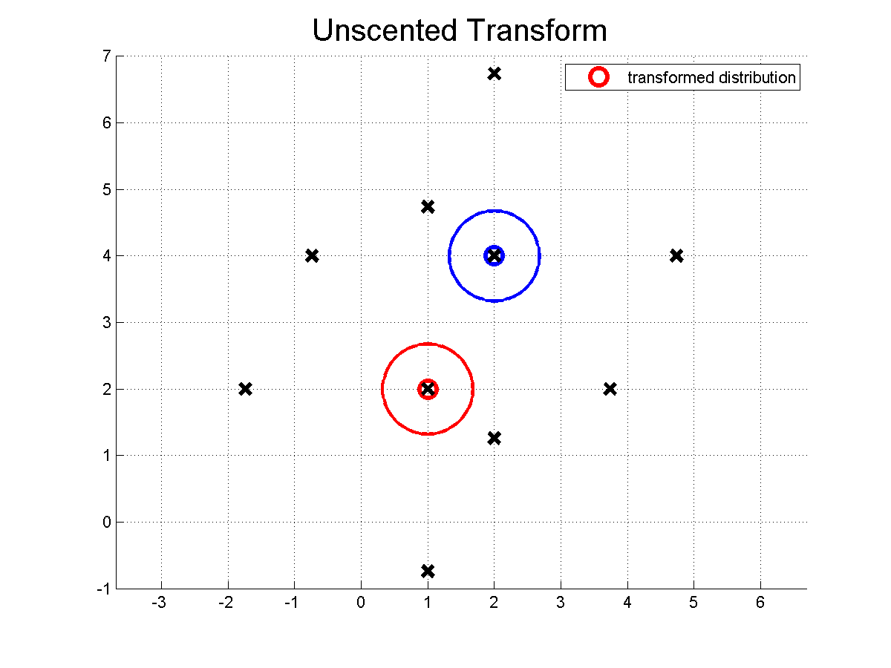

Figure 4: alpha = 0.1 Figure 5: alpha = 5

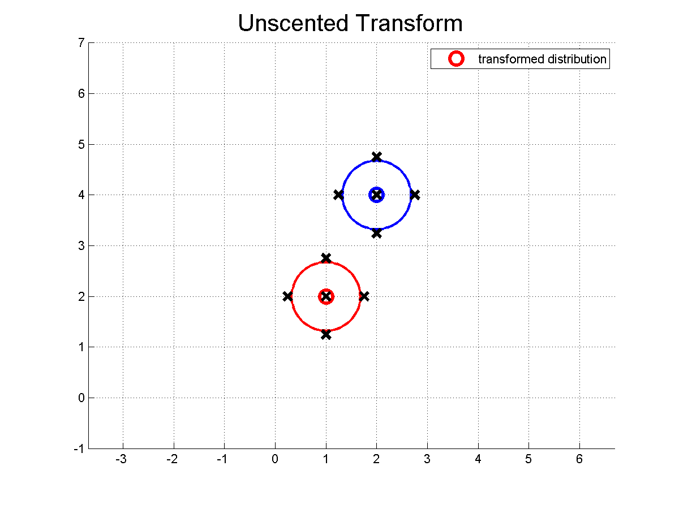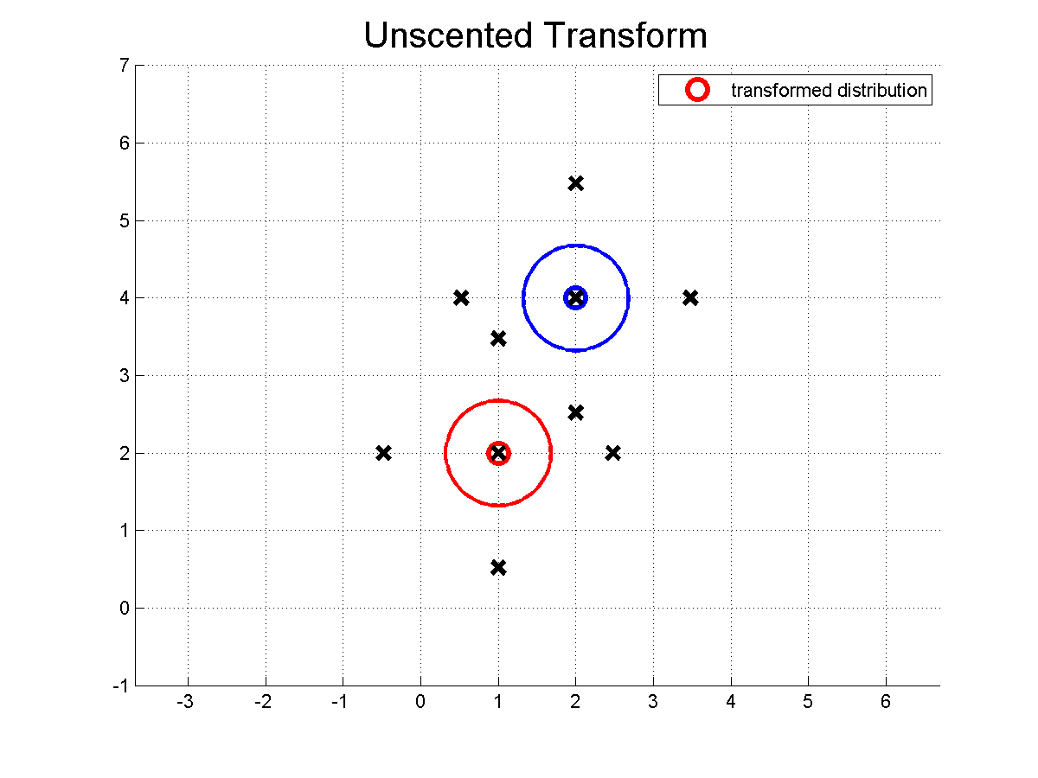

Figure 6: kappa = 5 Figure 7: kappa = 25